Thank you for praying for my one week trip to a church plant in Redentora where I taught a music training seminar. I taught tweens, teens and adults alike in the areas of music reading, conducting, the recorder, basic piano and voice technique. I had a former student, now adult friend, join me, and she was a blessing and great help to me. The week went better than I imagined and Lord-willing we will do it again next year, incorporating other teachers and music philosophy.

By way of family blessings, Dad loves to teach and this coming Sunday he will be filling in as the Sunday school teacher at Vila Nova on mother’s day. Pray for him too! It has a great blessing to see him serve the Lord after praying so many years for his salvation!

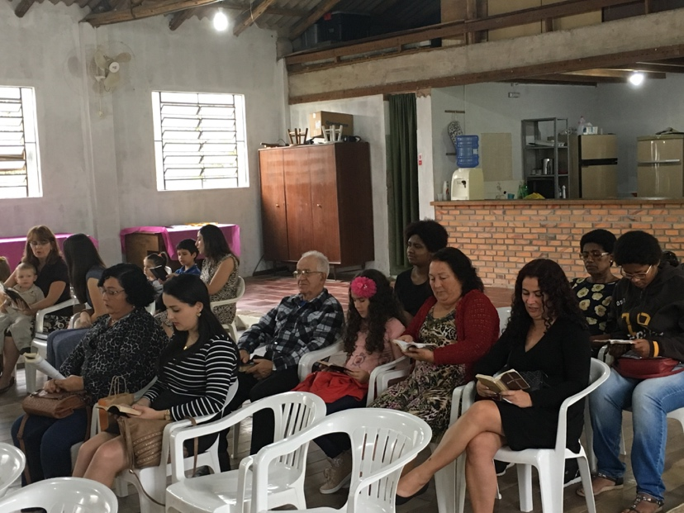
3rd Anniversary and Baptismal Service at Biblical Faith Baptist Church in Lami

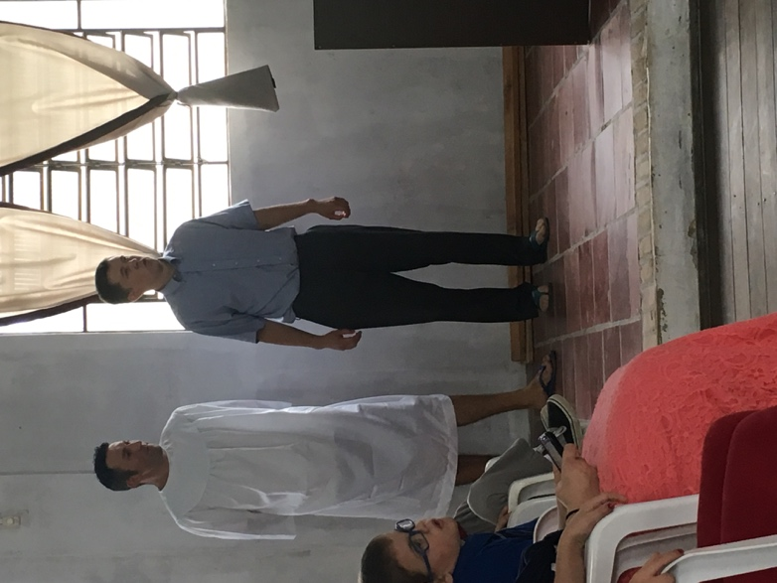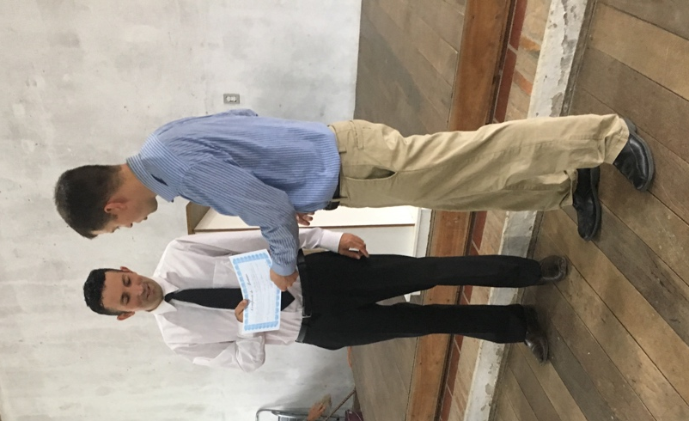
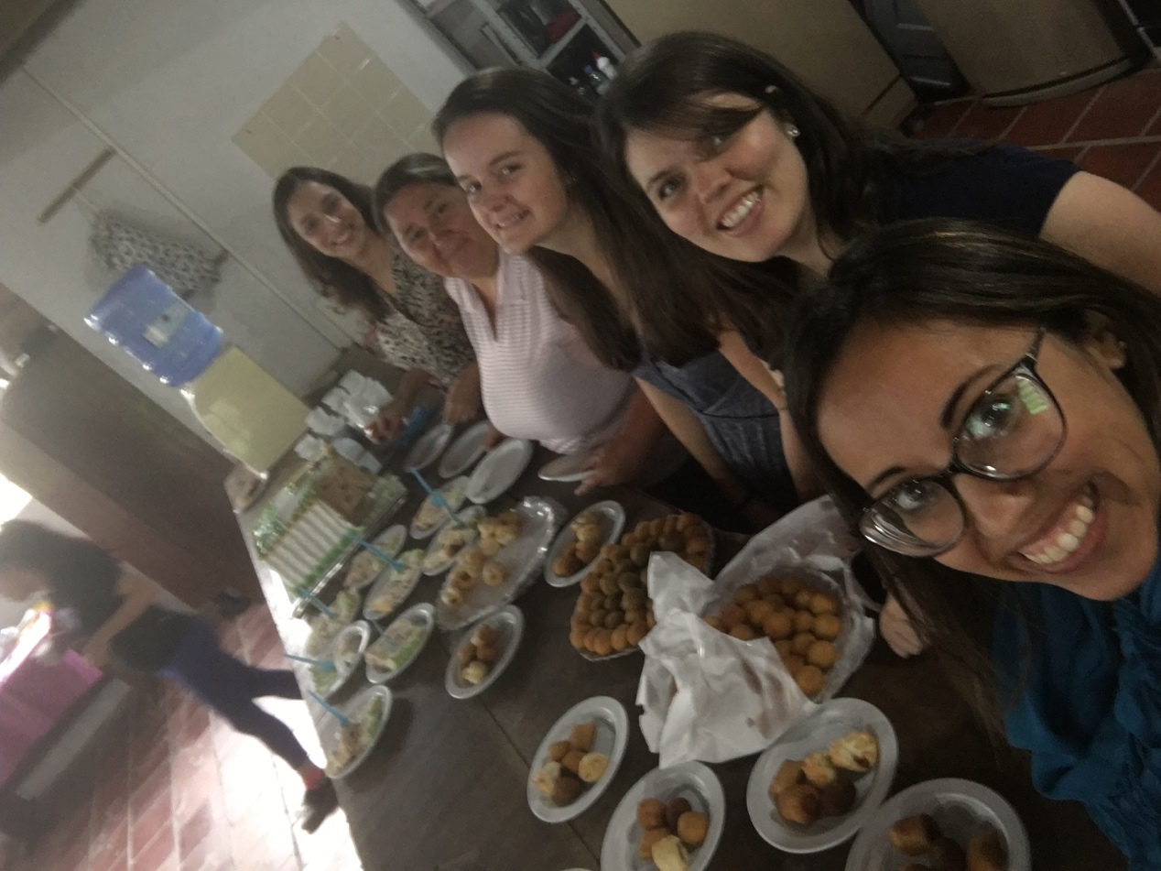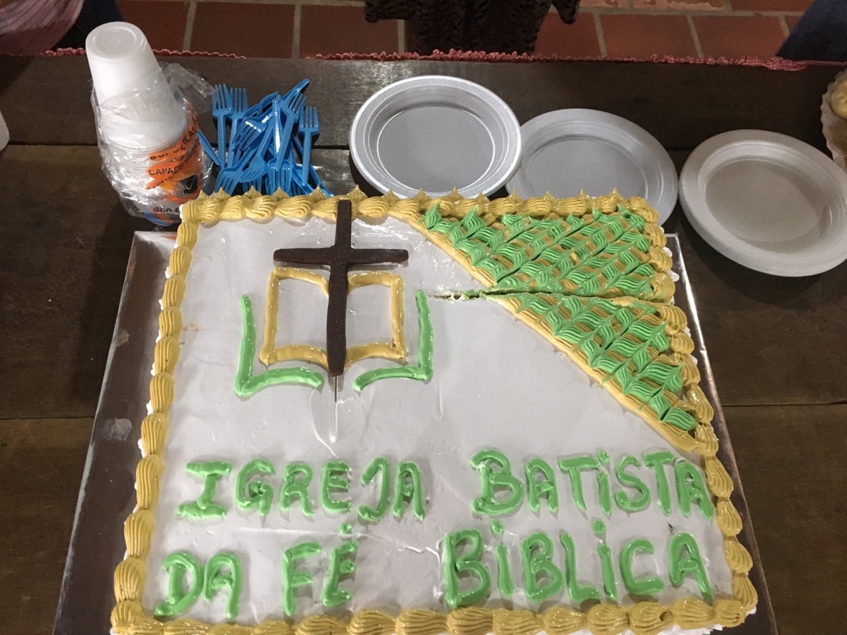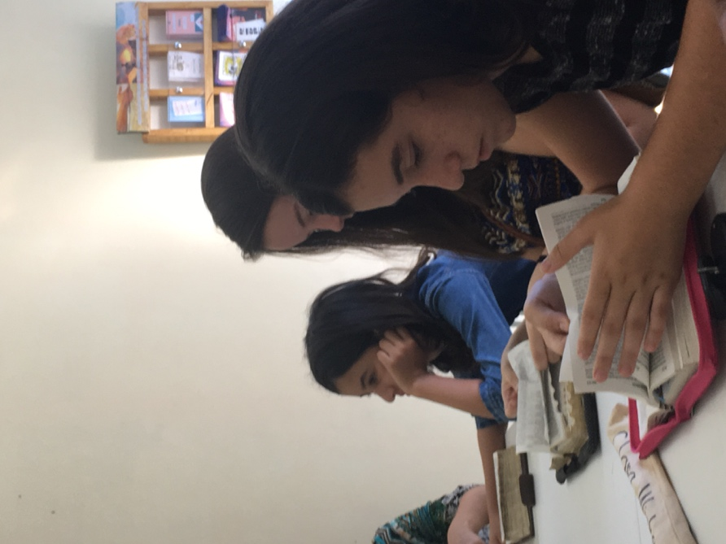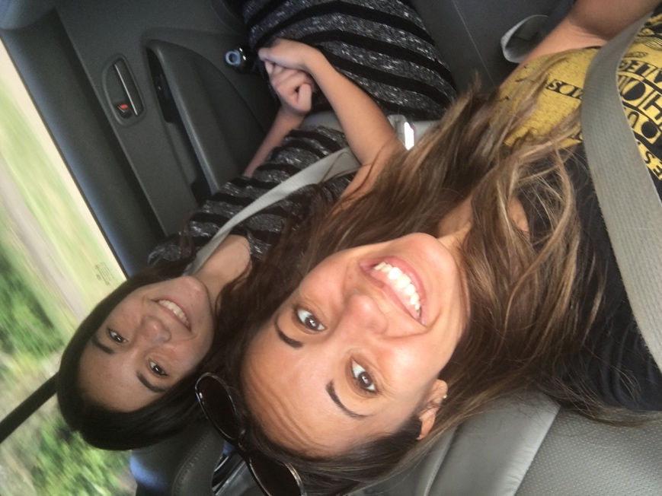
Learning and “going” blitzing and soul-winning with the girls at Vila Nova (top two pictures)
‘
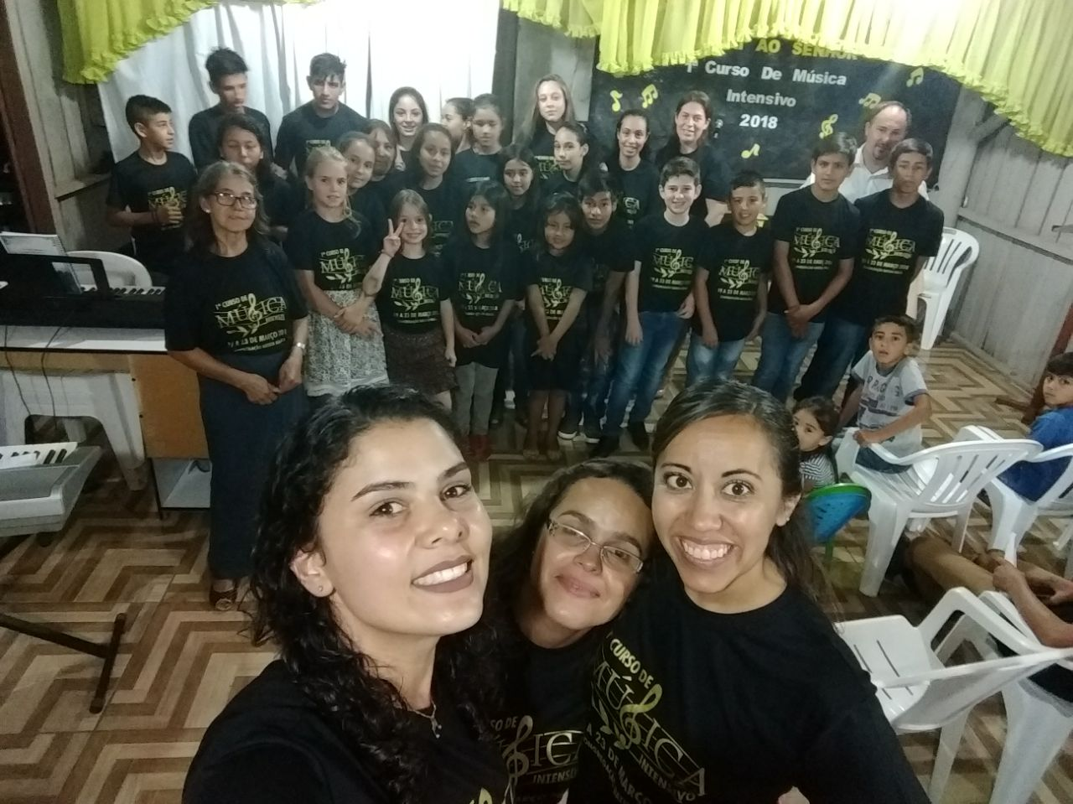
Giving a one-week Music Seminar at a church plant ministry Vila Nova supports.

