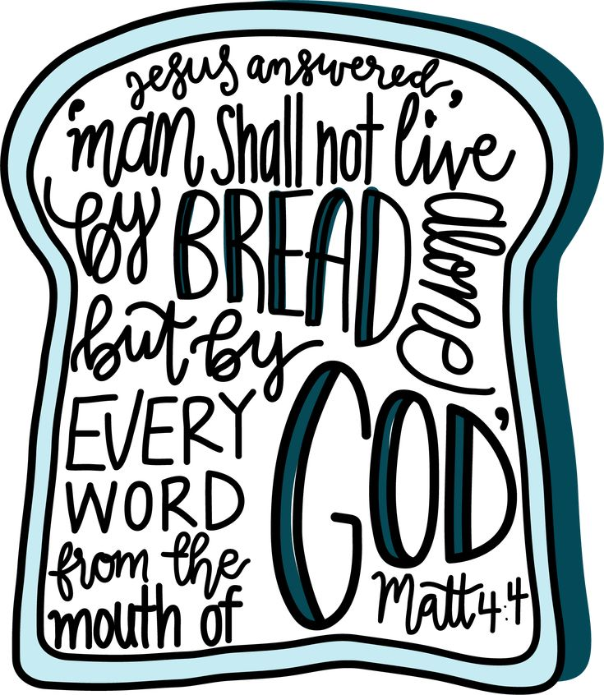

August Memory Verse
“Cast your burden on the Lord, And He shall sustain you;
He shall never permit the righteous to be moved.”
Psalm 55:22 NKJ
Don’t Forget
Our shoeboxes still need a little help getting to where they’re going. It won’t be long before our shoeboxes are ready to travel. A $10 donation per box helps cover shipping and processing which gets that special box into the hands of a child. All donations can be given to John. Money given: $300
Prayer Team News
Tuesday’s from 9:00 AM to 9:00 PM. A dedicated prayer team is essential to a church. It yields spiritual benefits with answered prayer for our church. We are inviting the presence in the power of the Holy Spirit to work with a strong connection while seeking God’s will for direction concerning a new pastor. Please help us pray together.
“Again, truly I tell you that if two of you on earth agree about anything they ask for; it will be done for them by my Father in heaven. For where two or three gather in my name, there am I with them.” Matthew 18:19-20
.
Wednesday Night
Make plans to be here Wednesday night as we share our prayer concerns and conduct our business meeting. The Pastor Search Committee will also meet.

This Week at a Glance…
Sunday, August 30
11:00 Morning Worship Service
Wednesday, September 2
6:00 Prayer Time/Business Meeting
Search Committee Meeting

usiness Meeting
Welcome

Order of Service August 30, 2026

Welcome
Announcements, Scripture, Prayer……..…….…Roger Keys
Congregational Songs ~Red Book~
Hymn #124……………………………………..Living By Faith
Hymn #259……………………………..…….Revive Us Again
Hymn #167…………………….Where We’ll Never Grow Old
Giving of Tithes & Offerings
Special Music by Doug Madaris
Message from God’s Word……………….........Rev. Tim Hall
“Not By Bread Alone”
Matthew 4: 1-4
Invitation Hymn #244………………………….....Just As I Am

Prayer Concerns
Daryl Abbott-kidney cancer
Daniel Berryhill-David’s son
David Berryhill-surgery recovery
Mike Berryhill-David’s brother
Richard Campbell-Linda’s son
Mike Evans – back surgery
Faye Franklin
Michael Harp-cancer
Hegwood family & baby Tuff
Susan Hentz
Tommy Kennedy-cardiac issues
Lamar Lea-knee surgery
Randy Luttrell
Charles McElhaney
Sue Miracle-health issues
Wayne Nation
Mike & Rita Parrish
Voncille Phillips-Alzheimer’s
Aydan Pitts-Bobbie’s grandson
Sandra Stansel-cancer
Brenda Williams
Bethel Baptist Church
Our nation & its leaders
Unspoken requests
Lost/Not in Church

Shut Ins:
Jo Burrows
Ann Dockery
Ozzie Jenkins
Glenda Sehorne-The Canopy
Burmah Teague-Morning Pointe

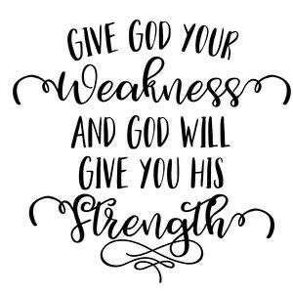

Visitor’s Card
Welcome! We are delighted you have chosen to worship with us today. Our prayer is that you feel at home, experience the love and presence of our Lord Jesus Christ, and are encouraged through our time of worship together. If we can serve you in any way, please let us know. We are thankful you are here!
Date
_____________________________
Name _____________________________
Address _____________________________
City
_____________________________
State
_____________________________
E-Mail _____________________________
Cell Number _____________________________
Home Number _____________________________

AGE GROUP
- 12-15
- 16-20
- Young Adult
- Adult
- I have moved into the area.
- I am looking for a church home.
- I would welcome a visit/call from a church member.

If Jesus waited 3 days…you can wait too.

Before you give up on God’s timing, remember this: Even Jesus had to wait 3 days.

Noah waited 120 years for the rain that no one believed would come.
Abraham waited 25 years for a son he was promised but couldn’t see.
Joseph waited 14 years in prison for a crime he didn’t commit.

If God makes you wait, trust Him.
If He delays your plans, seek Him even more.

Waiting isn’t wasted –
It defines you, humbles you, strengthens you, and prepares you for what’s ahead.
God’s timing isn’t punishment, It’s preparation.
His plans are always greater than ours.

So don’t quit.
Don’t rush.
Don’t doubt.

If the cross wasn’t the end of the story, your waiting isn’t either.
Welcome to
Bethel Baptist Church
We exist to serve our community by sharing Christ’s love and exalting Him with our lives.

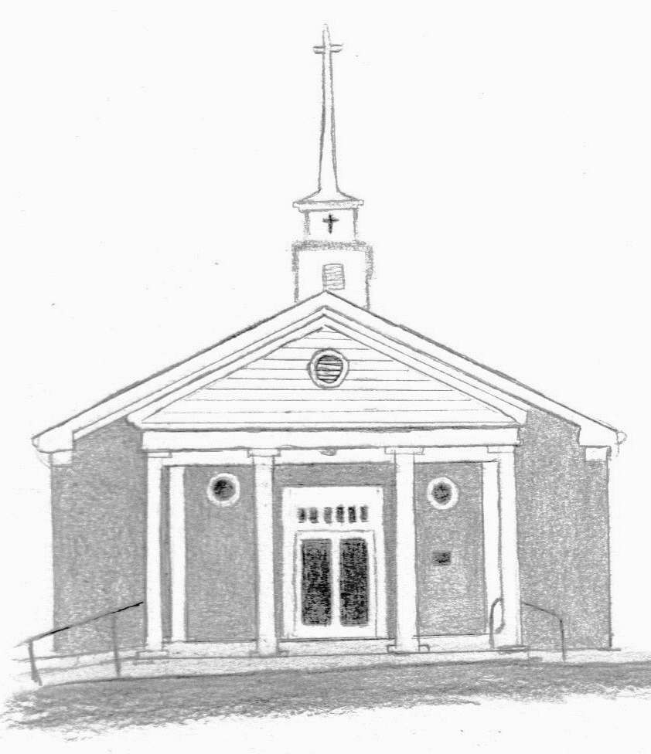

4068 HWY 341
Chickamauga, Georgia
(706) 375-3756
www.bethelbaptistchickamauga.com

