
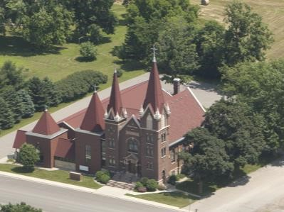
Friedens Evangelical Lutheran Church
Wisconsin Evangelical Lutheran Synod (WELS)

CHURCH OFFICE HOURS | WORSHIP SERVICE TIMES
Monday – Friday: 9:00 a.m. – 12:30 p.m. | Sunday: 9:00 a.m.  Tuesdays: 6:30 p.m.  Twice a Month  (See Schedule on EFriedens.com)  Saturday: Noon  Online: EFriedens.com

Rev. Henry T. Koch

REGISTRATION FORM

Event Name: Vacation Bible School Date of Event: August 12-13, 2026

From Website: (Under Ministries tab) Please Download the registration form, click Enable Editing, then fill it out (tab and type)(one form per child), save, print and e-mail it back to flcsec@bevcomm.net. To register the day of the event, please arrive at the church 15 minutes early. If you have any questions or concerns, please contact the church office (952-758-2828 or flcsec@bevcomm.net).

STUDENT INFORMATION
First Name: Nick Name: | Last Name:
Age:  Please note the age range for students to attend the church event is 3 (accompanied by parent) through 5th Grade. | Home Church:  City/Town:
Gender: M F | Allergies:
It would be nice if my child is placed in the same group as (child’s name). | Medical Issues or Special Needs:
PARENT/GUARDIAN INFORMATION
First Name: | Last Name:
Street Address: | Home Phone: Cell Phone:
Street Address: | Emergency Phone:
City: State: Zip: | E-mail:
How did you find out about our Vacation Bible School?
ALTERNATE PICK-UP PERSON INFORMATION
First Name: | Last Name:
Street Address: | Home Phone:
Street Address: | Cell Phone:
City: State: Zip: | E-mail:

Medical Release: I give my permission for the VBS staff to administer basic first aid to my child (named above) in the event of an injury. I understand that the event staff will contact emergency services in the event of a significant injury and all expenses for such emergency services will be paid by me.

Photo Release: I hereby grant the above-named church permission to copyright and use photographs/videos taken at the event of the minor designated above in any manner or form for any purpose lawful at any time. I waive any right that I may have to inspect or approve the finished product or written copy, that may be used in conjunction therewith, or the use to which it may be applied.

Permission to Attend: I give permission for my child (named above) to attend the church event. I understand that the information I give for this registration will only be used by the event-hosting church.

RELEASE & PERMISSION: First Name: | Last Name: | Date:

