Morning Worship
June 28, 2026, 11:00am
“Building Faith, Serving Together”
WELCOME & PRAYER

SONGS OF PRAISE & WORSHIP

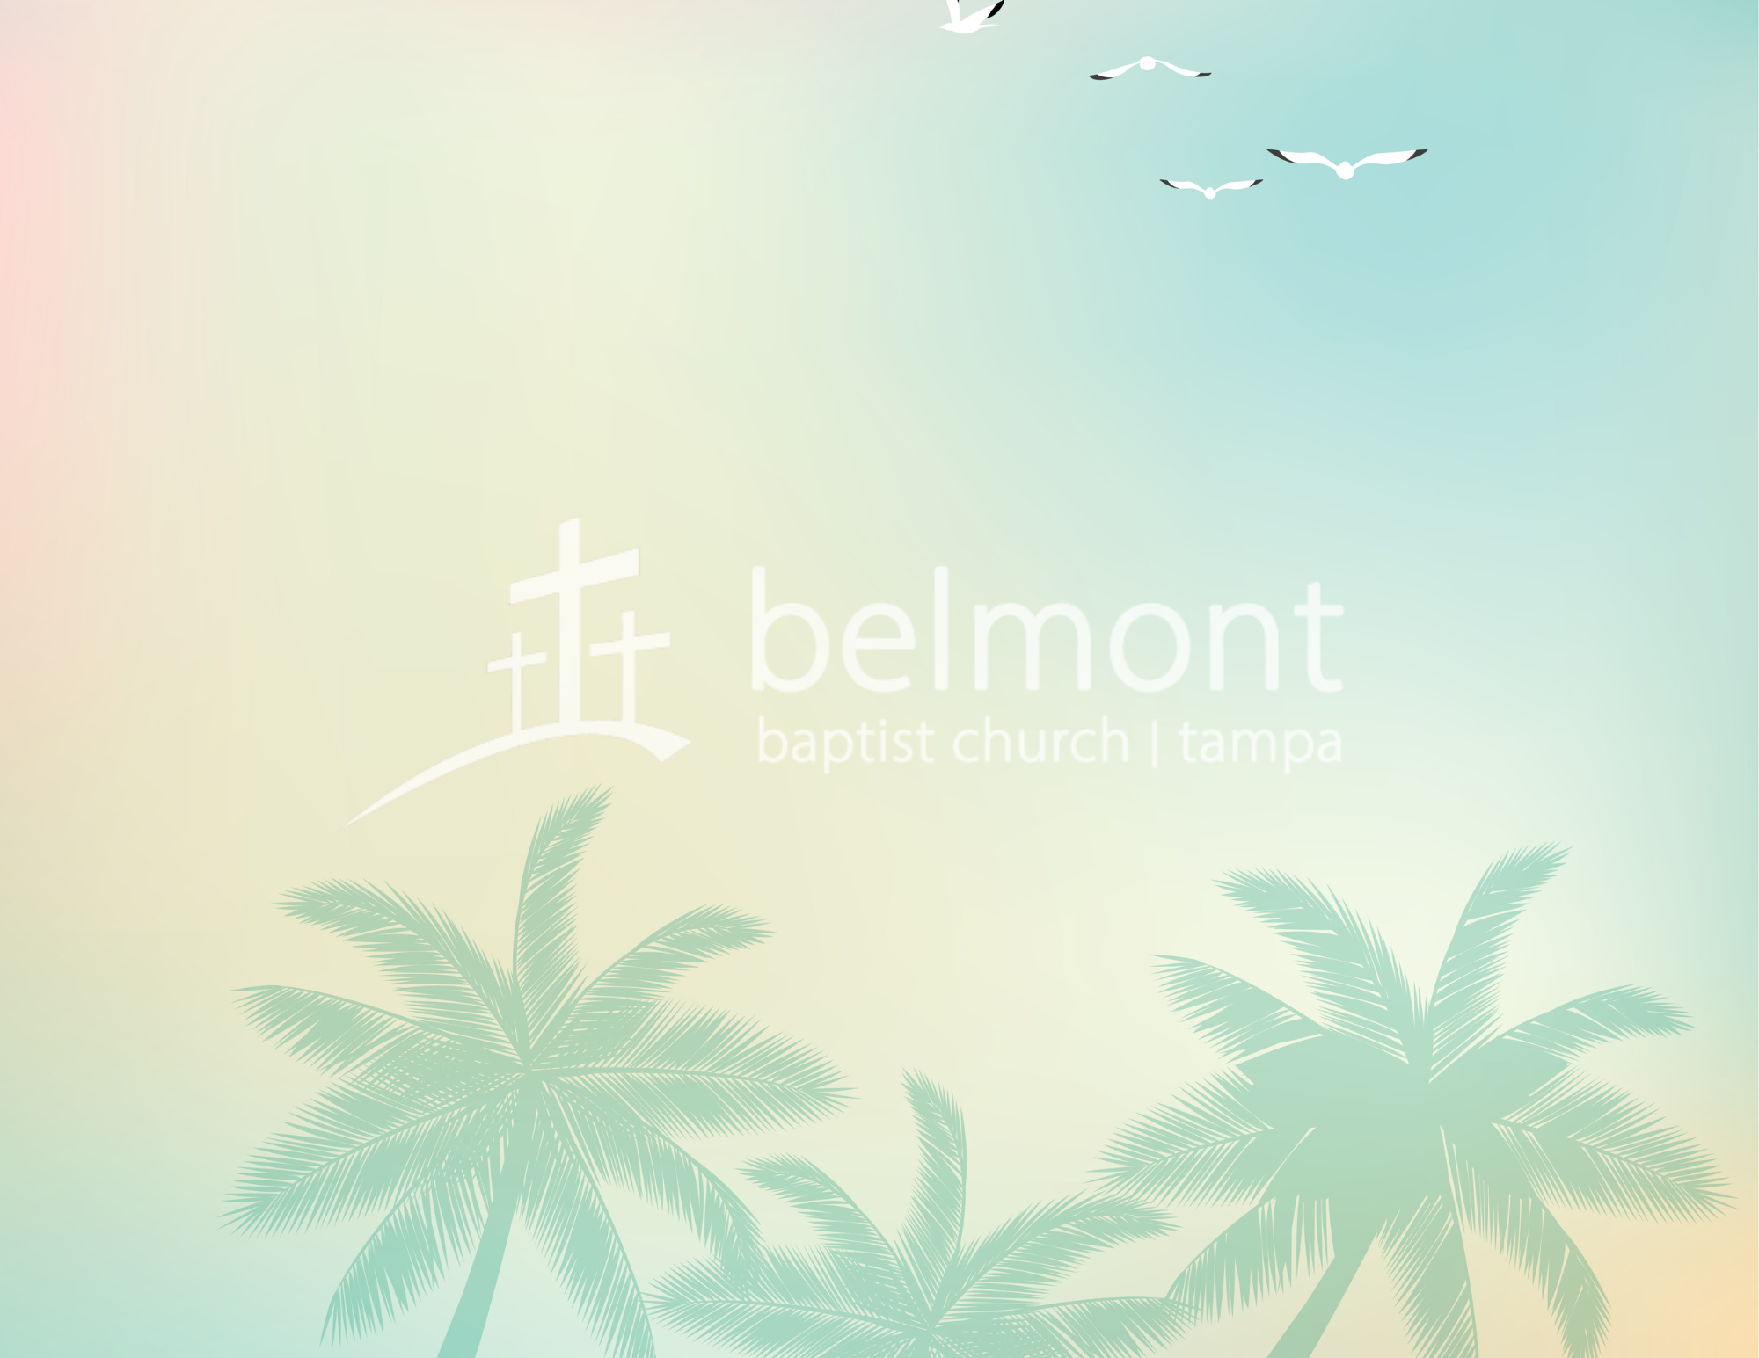
GIVING BACK HIS TITHES AND OUR OFFERING

MESSAGE FROM GOD’S WORD
Becoming People of Prayer– Part 2 Ephesians 1:15-19
Pastor David Proffitt

DEPART TO SERVE




“I do not cease to give thanks for you, remembering you in my prayers,” Ephesians 1:16

This Week at Belmont & Hill City...
SUNDAY, June 28th
9:45 AM…Small Group Gatherings
11:00 AM…Morning Worship
6:00 PM…Evening Service
MONDAY, June 29th
5:00 PM…Deacon’s Meeting
TUESDAY, June 30th
11:00 AM…Personnel Committee Meeting
WEDNESDAY, July 1st
10:00 AM…Hour of Prayer A-102
11:15 AM…Bible Study – Choir Room
FRIDAY, July 3rd
11:00 AM…Finance Committee/Contingency Planning
SATURDAY, July 4th
Holiday – No breakfast – Happy Independence Day !
12:00 PM…Fourth of July Celebration - Potluck

BIBLE STUDY – Join us as we study of AW Tozer’s, The Pursuit of God, with Les Eighmey, on Wednesday, Jul 1st, immediately following the Hour of Prayer. The book focuses on developing a deeper relationship with God. All are encouraged and welcome to attend.

FOURTH OF JULY CELEBRATION – We will come together at 12PM on Saturday, July 4 to thank God for the freedoms we have in Him and to thank Him for our nation. Join us for a potluck lunch and fellowship. Sign up at the Welcome Center Desk. Let us know what you are bringing.


DINNER AND HYMNS – Join us and invite a friend on Sunday night, July 12th as we have an old-fashioned hymn sing-along followed by a spaghetti supper. Be There. Be Blessed.

FELLOWSHIP LUNCH – Join your church family for lunch. Lunch is provided every Sunday, following the morning worship service. Want to contribute? Sign up with friends to provide lunch one Sunday. There is a whiteboard in the Fellowship Hall by the coffee bar for sign up. Thank you.

FAMILIES WITH CHILDREN – We’re glad you’re here. Certified Child Care is available. Inquire at the Welcome Center Desk. Children are always welcome in the service. If they become unsettled, feel free to step into the foyer. Livestream is available there so you won’t miss a thing. Thank you for helping create a welcoming space for all.
Deacon of the Week
Les Eighmey – 813-614-3284
The Deacon of the Week is available for emergencies or a need if you are unable to get in contact with the office.

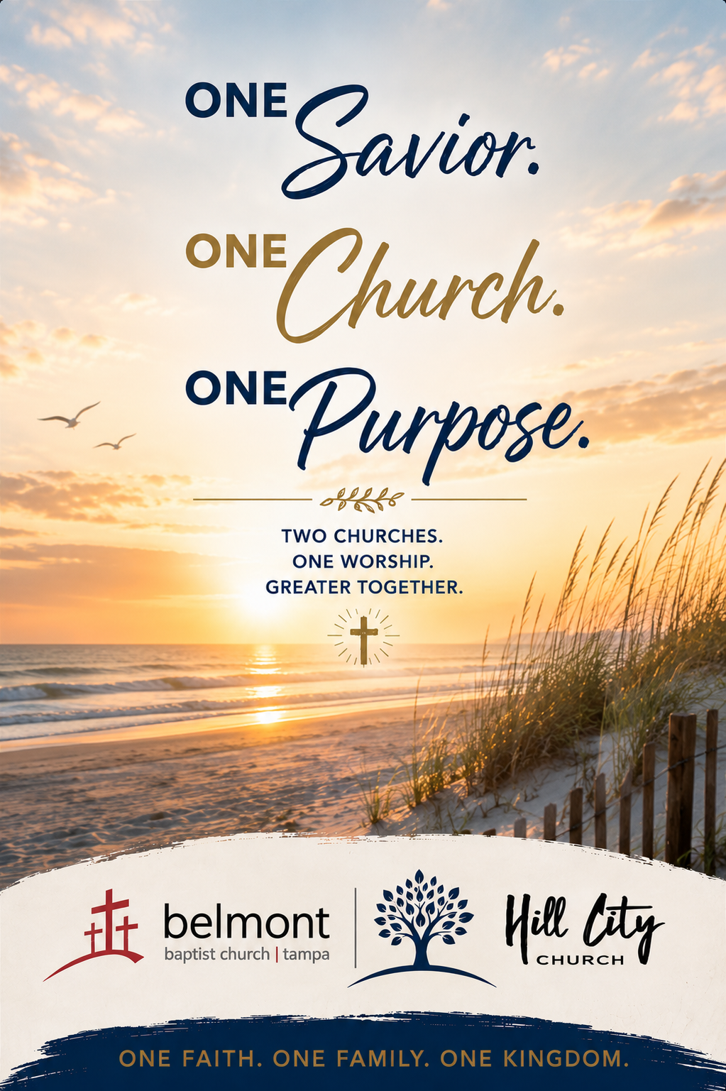

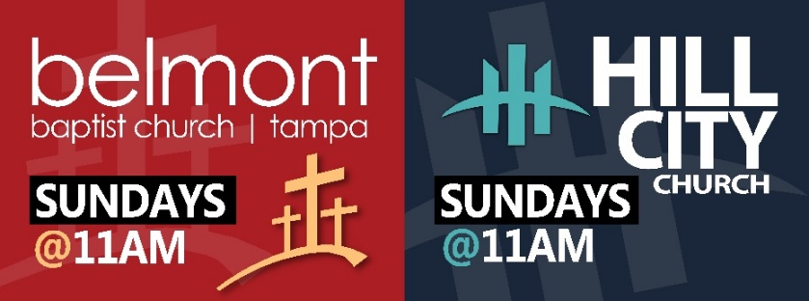





Hill City - QR Code

7830 N. 56th St
Tampa, FL 33617
813-988-1501
www.belmonttampa.org
www.hillcitychurchtampa.org

Like us on Facebook
Belmont Baptist Church Tampa
Hill City Church Tampa
God is good all the time. All the time God is good.

Two Churches/One Purpose
Growing God’s Kingdom Together
Belmont offering/tithe options available at www.belmonttampa.org

June 28, 2026

