DEAR PARENTS:
We realize that you, as parents, are the primary faith influencers in your child’s life. The best disciple making takes place when students’ parents take the lead. That’s why we’ve created this helpful guide for you to use at home with your child. It is designed to give you some basic information about what is being taught at church through the Pursuit curriculum, which shows how God draws near to us as we draw near to him, along with some helpful tools and questions to help you reinforce this learning at home.

MAIN TOPICS, SCRIPTURE, TAKEAWAYS & MEMORY VERSES
ABUNDANT LIFE
These four lessons look at how life with Christ is the best life. When we abide in Jesus and look toward eternity with him, we experience abundant life here and now.
LESSON 1  The Good Life  (John 10:10, Psalm 16)  THE TAKEAWAY  Jesus gives his followers abundant life. | 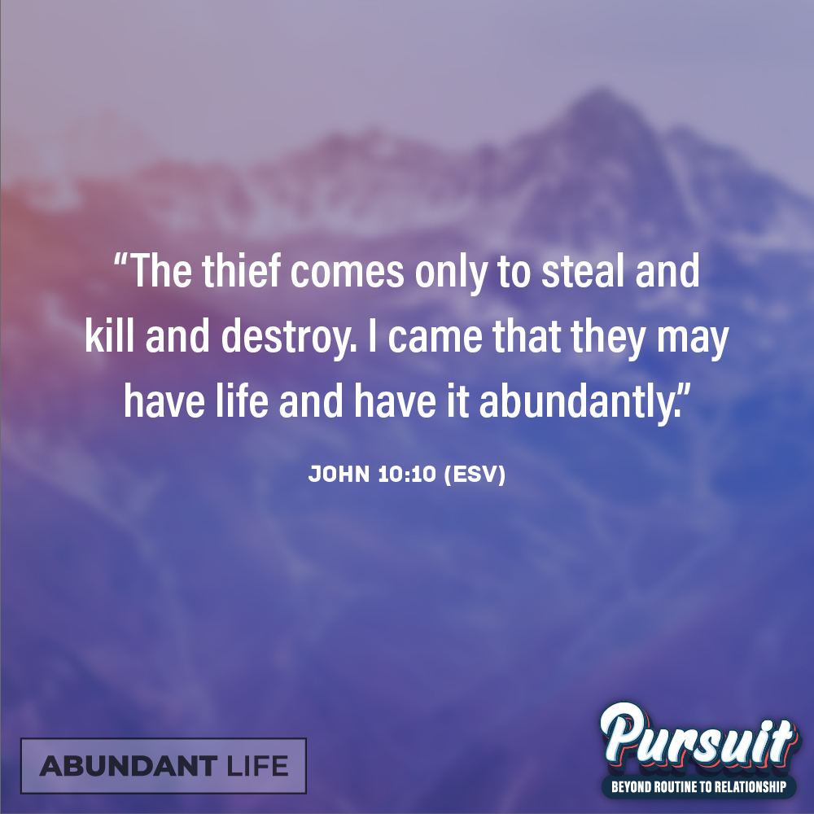
LESSON 2  Life on the Vine  (John 15:1–17)  THE TAKEAWAY  We must abide in God in order to experience abundant life. | 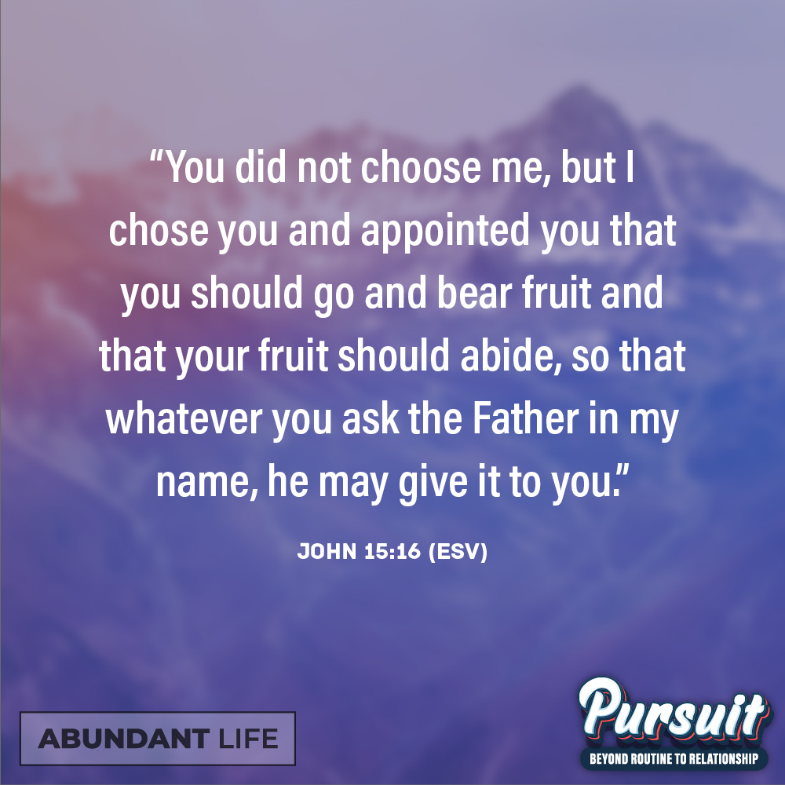

LESSON 3  When the Good Life Hurts  (2 Corinthians 4:7–18)  THE TAKEAWAY  Abundant life does not mean that everything is always easy. Having an eternal perspective helps us find abundance in suffering. | 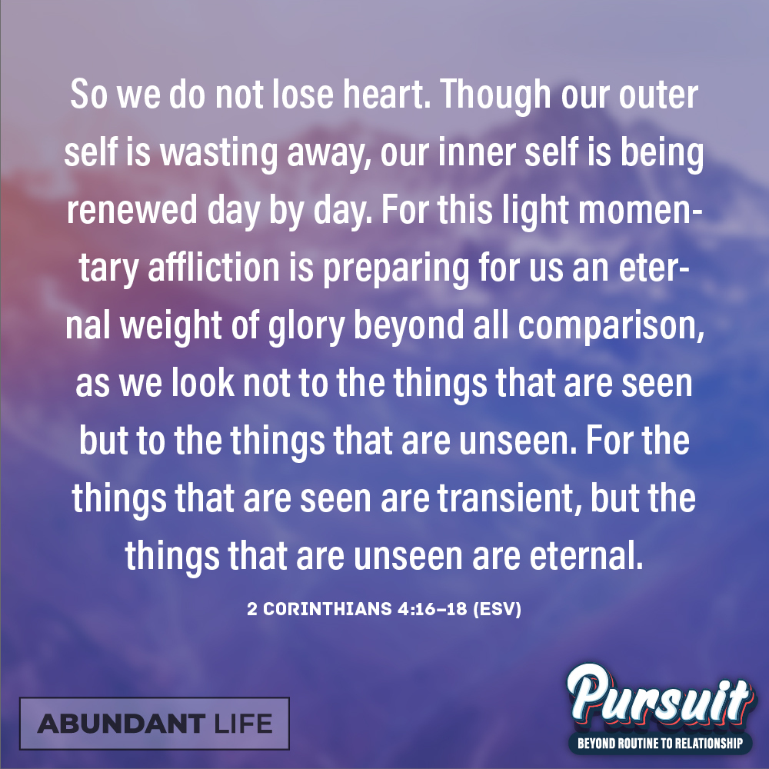
LESSON 4
Eternal Life
(Revelation 21)

THE TAKEAWAY
Eternity with God in heaven is the culmination of abundant life.

QUESTIONS TO ASK
Here are some conversation starters to help you talk with your child about what they’re learning:

- What do you consider “the good life”?
- What are your thoughts about eternity and heaven? Is it something that you look forward to, something that scares you, or something you don’t really think about much?

