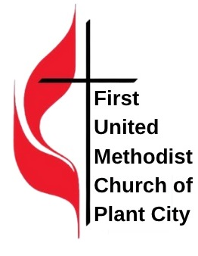
The Bruton Scholarship
First United Methodist Church Plant City, Florida

This application form will apply to The Bruton Scholarship which will be awarded for the fall semester. This application will only cover one year of eligibility. The student must maintain a 3.0 grade point average to qualify and maintain eligibility.
Transcripts must be submitted for each scholarship. The amount of the scholarship is based on the market, the number of hours, and/or the level of course material.
Fall 2026 APPLICATION FORM
Name ___________________________________________________________________________________

Address__________________________________________________________________________________

City __________________________________________ State______________ Zip ____________________

Phone _____________________________ Email ________________________________________________

Parent/Guardian ___________________________________________ Phone __________________________

University or College Attending ________________________________________________________________

What is your major? _________________________________________________________________________

What is your student ID number? _______________________________________________________________

Current GPA: _____ Select one: ____ Freshman ____ Sophomore ____ Junior ____ Senior Other: ________

Please read and initial each of the following. All items must be completed to be eligible.
_____I understand that these awards are for verified members of the First United Methodist Church Plant City only.
_____I have been a member of the First United Methodist Church Plant City for at least one year.
_____I understand the scholarships are not in cash. A check will be made out to the school directly.
_____I have completed all pages of the application.
_____I understand an interview may be scheduled during this process and could be held remotely.
_____I have attached the following:
1. A letter of recommendation from a member of the First United Methodist Church.
2. A letter of recommendation from a school faculty or administrative staff member.
3. A copy of my transcripts for the previous semester of the school that I’m attending.
** Letters of recommendation are valid for one year.

_______________________________________________________ __________________________
Signature of Student (Must be signed only by the student) Date

Application Faith Statement: Must be updated for each scholarship application. What is the importance of your faith? How do you plan to continue to be a follower of Jesus Christ? How will you be an active Christian on your school campus? Use additional paper if needed.
______________________________________________________________________________________________________________________________________________________________________________________________________________________________________________________________________________________________________________________________________________________________________________________________________________________________________________________________________________________________________________________________________________________________________________________________________________________________________________________________________________________________________________________________________________________________________________________________________________________________________________________________________________________________________________________________________________________________________________________________________________________________
IMPORTANT REMINDERS:
- Incomplete applications will NOT be considered.
- The Scholarship Committee may request an interview either in person, by Zoom, or by phone.
- The minimum grade point average to qualify and maintain eligibility is 3.0.
- The decision of the Scholarship Committee will be final.
Scholarships are exclusively for ACTIVE MEMBERS of the First United Methodist Church of Plant City. ACTIVE MEMBERS will be defined as having been a member of the church for at least one year and faithfully attend and participate in the life of the Church.
The deadline for this application is June 30, 2026 (Bruton Scholarshp).
Mail to:
Scholarship Committee
First United Methodist Church
Attention: Pastor Margaret Rountree
303 N Evers Street
Plant City, FL 33563

Or deliver the completed application to Reverend Margaret Rountree

